# Exercises: Creating Landing Pages

Problems for exercises and homework for the [“HTML and CSS” course @ SoftUni](https://softuni.bg/courses/web-fundamentals-html5). Submit your solutions in the SoftUni judge system at <https://judge.softuni.bg/Contests/408/Creating-Landing-Pages>.

## Search Job

Create a Web page (HTML5 + CSS3 + images) that looks and behaves like the screenshots below:

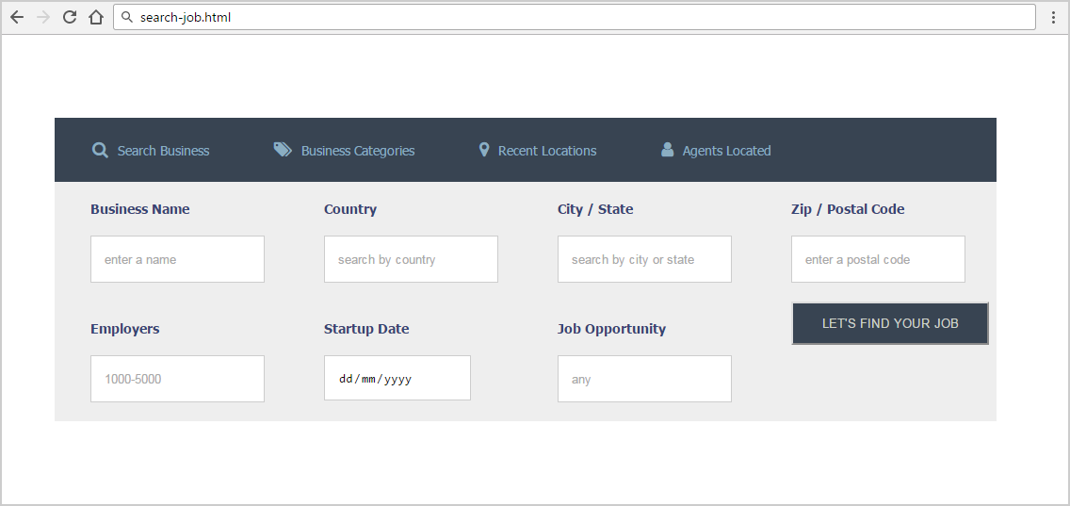

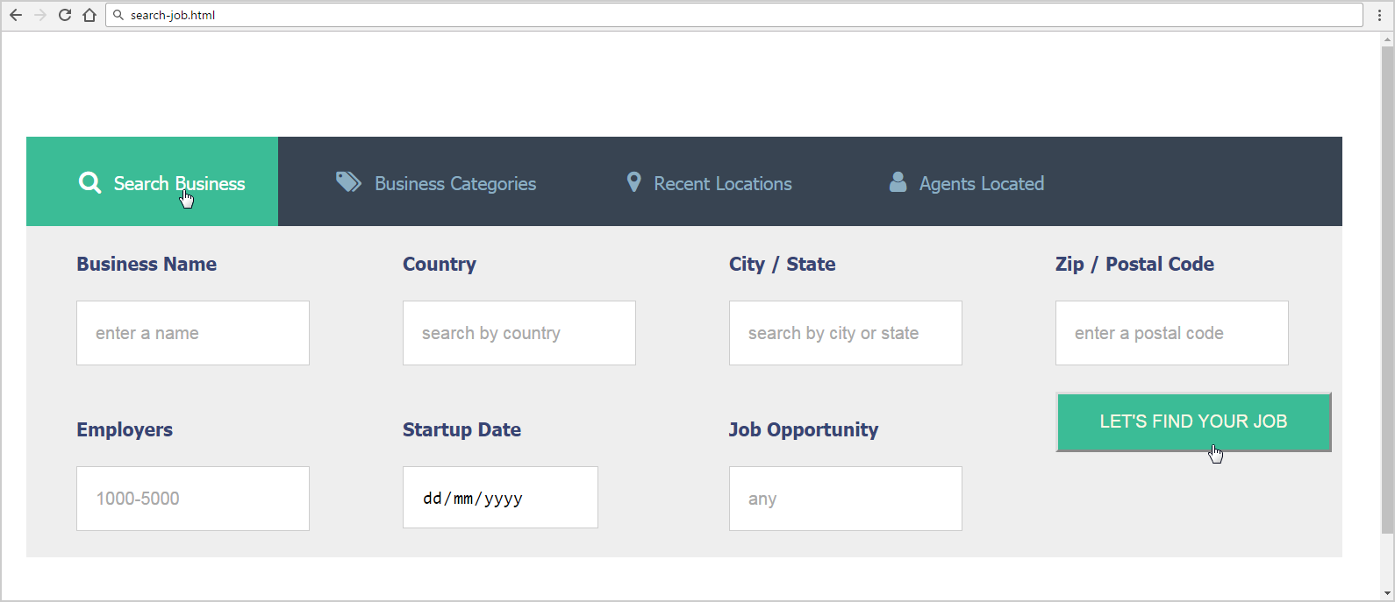

### Steps to Follow

Start with the **site header**:

* @import url('<https://cdnjs.cloudflare.com/ajax/libs/font-awesome/4.7.0/css/font-awesome.css>');
* <ul>, <div>, <nav>, <label>
  + Margin 0px;
  + Padding 0px;
* <body>
  + Text-size: 14px;
  + Font-Family: **Tahoma, Helvetica, sans-serif;**
  + Padding: **80px 50px;**
* <nav>
  + Width: 70%;
* Style the unordered list <ul> in the site navigation
  + Background-Color: #384452;
* Style the list items <li> in the site navigation
  + Display: **Inline Block**
  + Remove the bullets
  + Padding: 25px;
* Style hyperlinks
  + Remove the bullets
  + Margin Left: 15px;
  + Text Color: #8BAEC2;
* <a> before
  + Font Family**:** FontAwesome, serif;
  + Margin Right: 10px;
  + Font Size: 18px;

Test the site navigation in the browser:

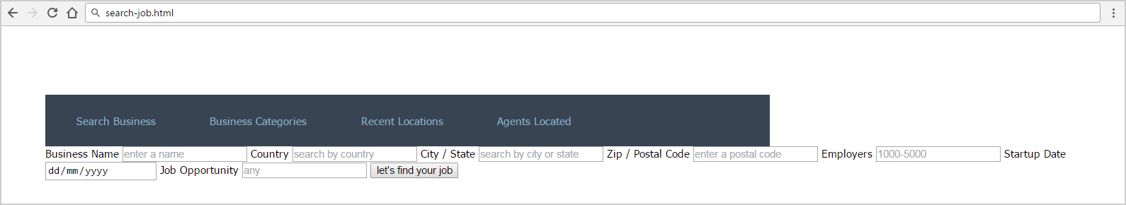

* li:first-child a::before
  + content: "\f002";
* li:nth-child(2) a::before
  + content: "\f02c";
* li:nth-child(3) a::before
  + content: "\f041";
* li:nth-child(4) a::before
  + content: '\f007';
* <li> hover
  + background-color: #3BBC96;
* <li> hover a
  + Text Color: #ffffff;

Test the site navigation in the browser:

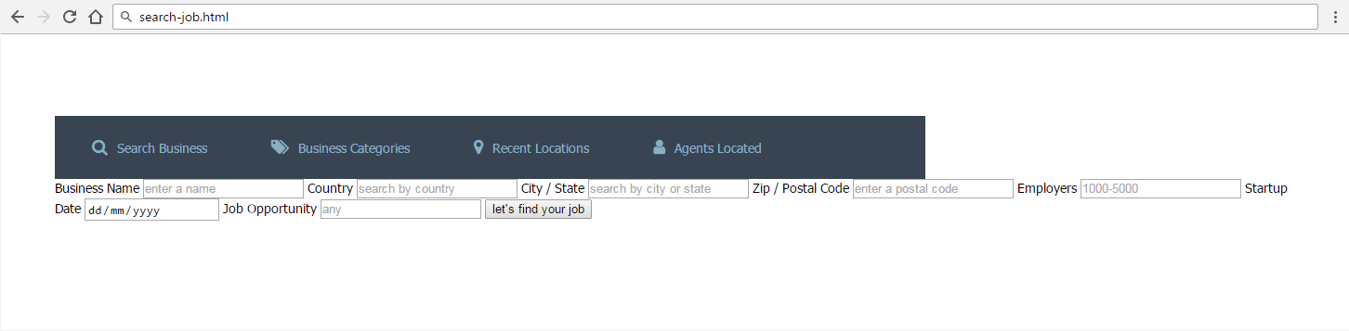

Style the Main content block:

* Make the background #EEEEEE
  + Use 70% width;
  + Display: flex;
  + Flex-Wrap: wrap;
* Label
  + Color: #374574;
  + Display: block;
  + Font Weight: bold;
  + Width: 210px;
  + Margin Left: 38px;
  + Margin Top: 20px;
* Input
  + Border: 1px solid #CDCDCD;
  + Margin Top: 20px;
  + Margin Bottom: 20px;
  + Height: 46px;
  + Padding Left: 14px;
* Button
  + Margin-left: 38px;
  + Width: 210px;
  + Height: 46px;
  + Text-transform: uppercase;
  + Background-color: #384452;
  + Color: #CED1CA;
* Button hover
  + Background-color: #3BBC96;
  + Color: #FFF7E4;
  + Cursor: pointer;

## Code Mesh Conference

Create a Web page (HTML5 + CSS3 + images) that looks and behaves like the screenshots below: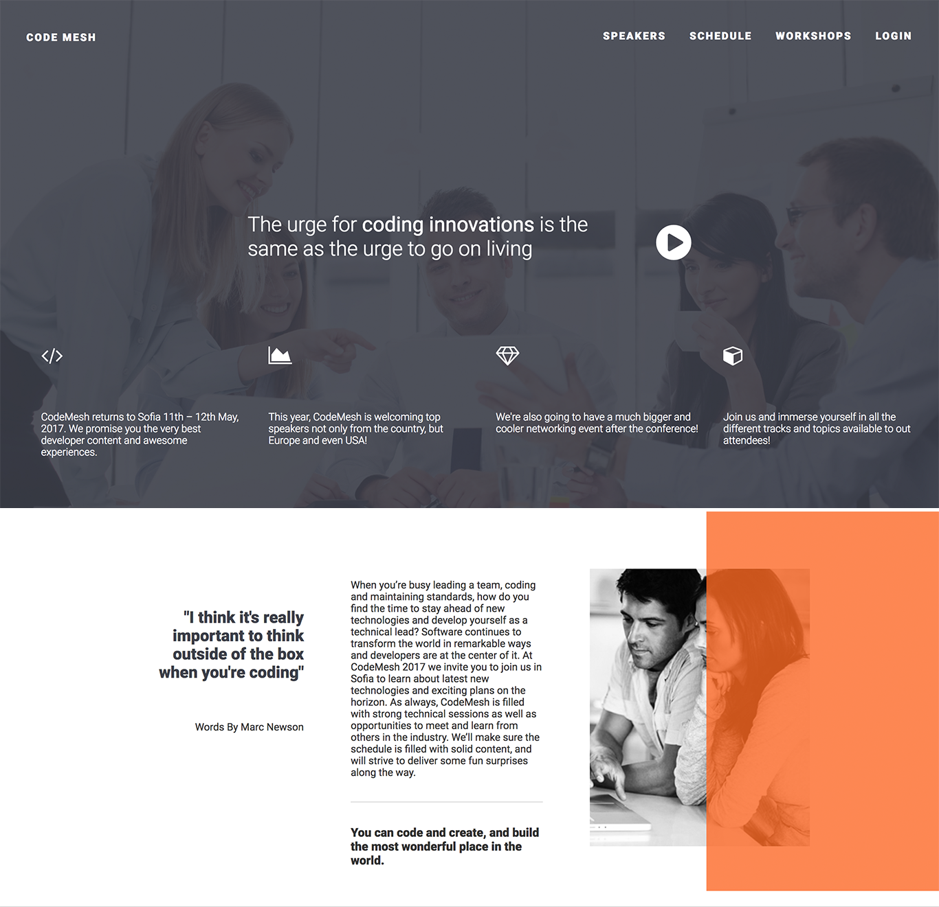

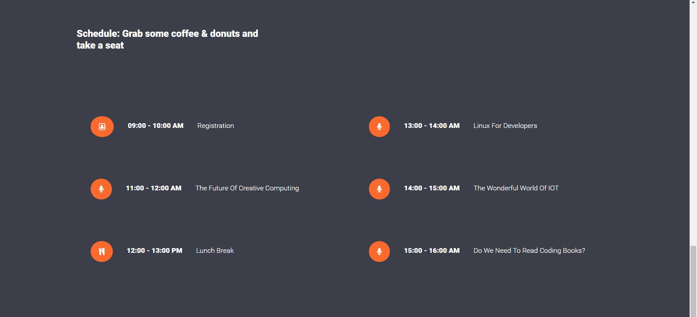

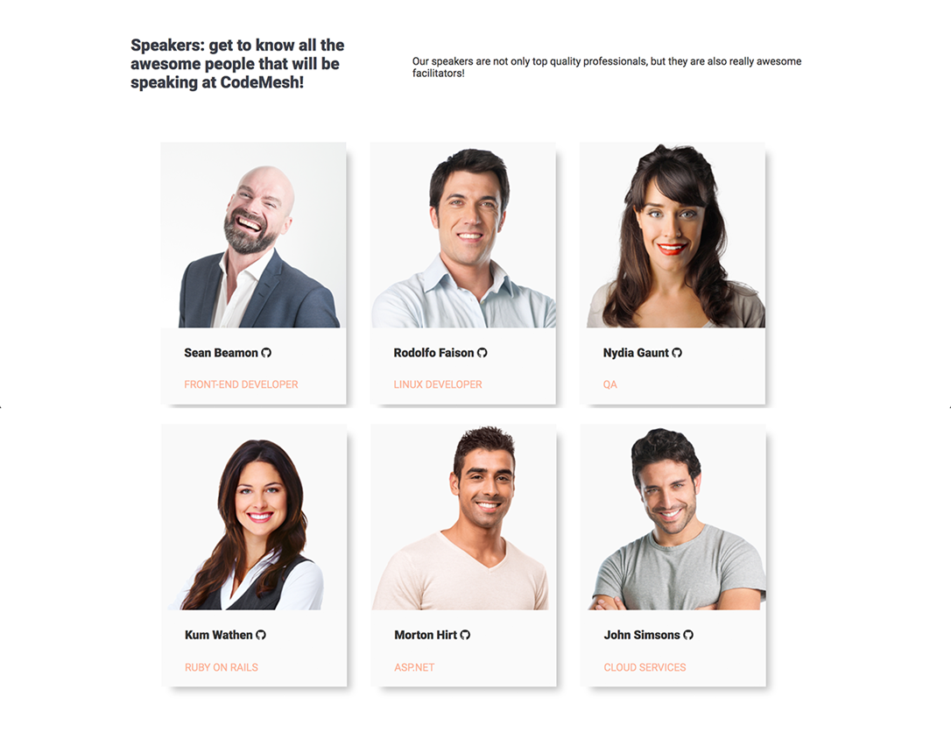

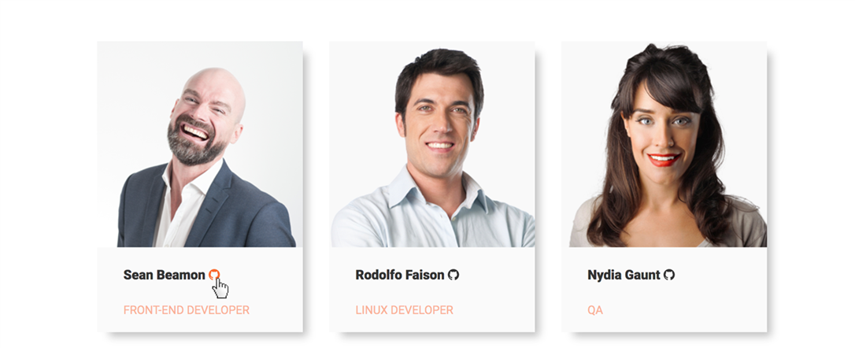

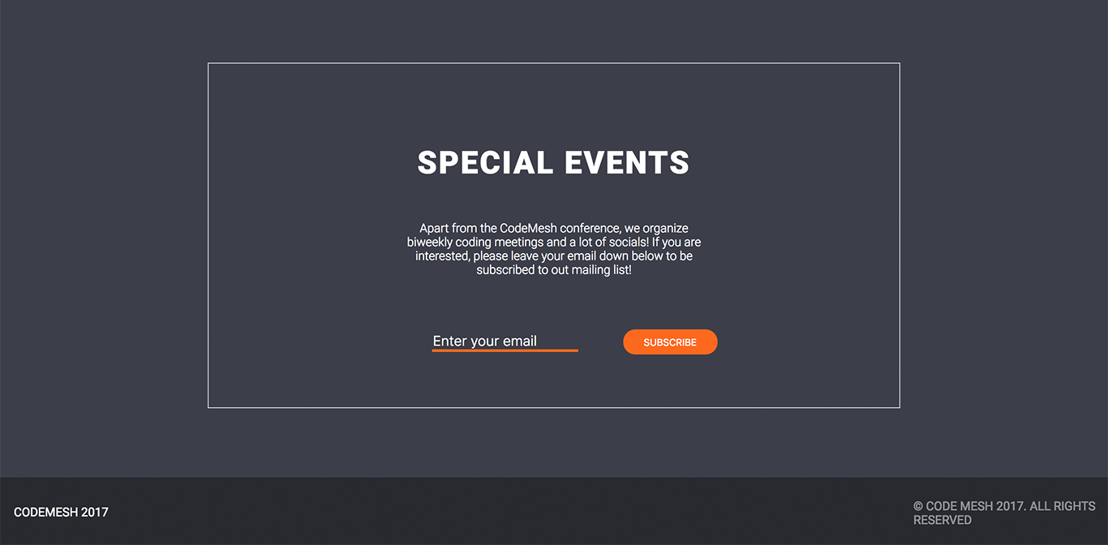

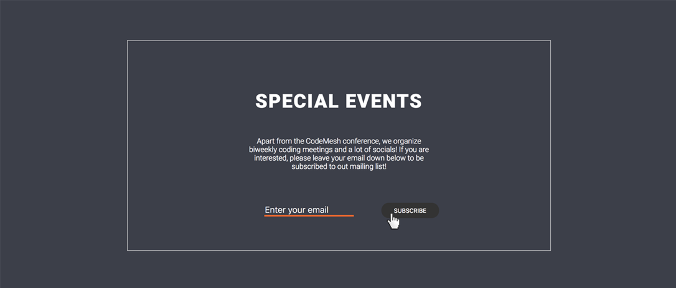



* The mouse cursors in the above screenshots explain what happens when the mouse moves over a project Start

### Input

You are given the above screenshots + the required font + all required images + the texts on the site.

### Output

The output should be valid HTML5 + CSS3 that implement the above Web site.

### Constraints

* Font: 14px “Roboto“,sans-serif;
* Background Colors: #ffffff, #3c3f49;
* Colors: #333333; #3c3f49; #fa692e;
* Pixel-perfect implementation is not required.

### Hints

Use the following **font**, **styles** and **CSS definitions** for the icons in the header, the icons in the schedule section and the GitHub links on the speakers section

* @import url('<https://maxcdn.bootstrapcdn.com/font-awesome/4.7.0/css/font-awesome.min.css>');
* <i class="fa fa-play-circle fa-4x" aria-hidden=“true"></i>
* <i class="fa fa-code fa-2x" aria-hidden="true"></i>
* <i class="fa fa-area-chart fa-2x" aria-hidden=“true"></i>
* <i class="fa fa-diamond fa-2x" aria-hidden=“true"></i>
* <i class="fa fa-cube fa-2x" aria-hidden="true"></i>
* <i class="fa fa-angle-down" aria-hidden=“true"></i>
* <i class="fa fa-address-book-o orange-icon" aria-hidden=“true"></i>
* <i class="fa fa-microphone orange-icon" aria-hidden=“true"></i>
* <i class="fa fa-cutlery orange-icon" aria-hidden=“true"></i>
* <i class="fa fa-github" aria-hidden="true"></i>

For the **speaker boxes** you may use:

* box-shadow: 10px 10px 15px -5px rgba(0,0,0,0.25);

For the **overlay on the header,** look up CSS background-image properties.

For the **overlay on the introduction section,** you may use a pseudo class or additional divs.

For **the sections that are full width,** they need to be expanded to the full width with the help of pseudo elements. **DON’T make the body width: 100% and fix the other containers with paddings.**